Design Document

**Digital Board Marker**

Audio Hardware Description

This module is designed and developed by   
Hamza Farooq (2016-CS-122)  
  
Supervised by  
Samyan Qayum Wahla

Date: Aug 14, 2019

Table of Contents

1. Document Purpose 6

2. Requirements Addressed 6

3. Detailed Design 6

3.1. Transmitter 6

3.1.1. Short Description 6

3.1.2. Component Diagram 6

3.1.3. Schematic Diagram 10

3.1.4. Component Connection Diagram 11

3.2. Receiver 12

3.2.1. Short Description 12

3.2.2. Schematic Diagram 12

3.2.3. Component Connection Diagram 12

4. Rules and Assumptions 12

5. Module Workflow Description 12

3.1. General Flow 12

3.1.1. General Flow Diagram 13

6. Tools and languages used 13

6.1. Arduino IDE v1.8.9 13

7. References 13

List of Figures

Figure 1 - Component Description 7

Figure 2 - Electret Microphone 8

Figure 3 - 100K Resistor 8

Figure 4 - Input Audio Jack 8

Figure 5 - Output Audio Jack 8

Figure 6 - Arduino nano 9

Figure 7 - nRF24L01 Adapter 9

Figure 8 - nRF24L01 Antenna Version 9

Figure 9 - Schematic Diagram 10

Figure 10 - Component Connection Diagram 11

Figure 11 - Transmitter Workflow 13

Figure 12 - Receiver Workflow 13

List of Tables

Table 1 - Revision History 5

Table 2 - Requirements Addressed 6

Table 3 - Component Description 9

**Revision History**

|  |  |  |  |
| --- | --- | --- | --- |
| **Author** | **Date** | **Version** | **Notes** |
| Hamza Farooq | Aug 14, 2019 | v1.0 | Document of first stable version of module |
|  |  |  |  |
|  |  |  |  |
|  |  |  |  |

Table - Revision History

# Document Purpose

This document addresses all functionalities, Structure, Workflow and detailed overview of audio hardware prototype. It describes requirements, design diagrams and structure diagrams, programming tools and languages used in designing and developing the hardware module.

# Requirements Addressed

|  |  |  |
| --- | --- | --- |
| **#** | **Requirement** | **Priority** |
|  |  |  |
| **1** | Transfer Voice data from one point to another. | HIGH |
| **2** | Transfer Voice data from transmitter to receiver wirelessly. | HIGH |
| **3** | Transmitter should be standalone in terms of power. | HIGH |
| **4** | Receiver should output voice data as analogue audio wave. | MEDIUM |
| **5** | Implement noise control knob in transmitter. | MEDIUM |

Table - Requirements Addressed

# Detailed Design

Audio hardware has two major sub-modules named as **Transmitter** and **Receiver**

## Transmitter

## Short Description

The objective of the Audio Transmitter is to get voice data from microphone and transmit it to the Audio Receiver. After getting the data from microphone, it converts analogue audio data into a digital Pulse Width Modulation or PWM wave.

## Component Diagram

Diagram of transmitter module with functioning components highlighted with numbered squares is given below

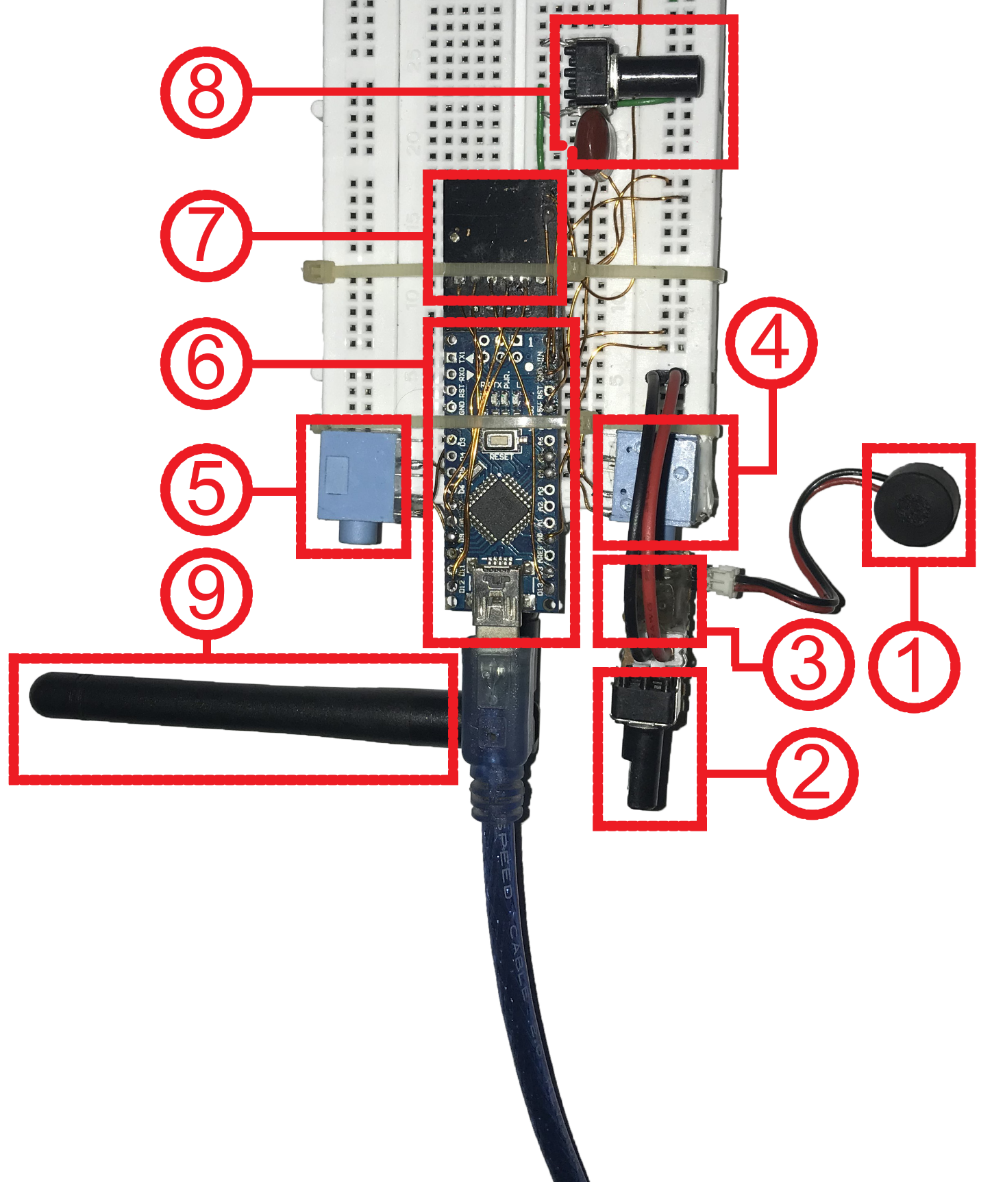

Figure - Component Description

|  |  |  |
| --- | --- | --- |
| **Component Number** | **Description** | **Diagram** |
|  |  |  |
| **1** | **Name:** Electret Microphone | Figure - Electret Microphone |
| **Detail:** 9767 Condenser Electret Microphone used to capture voice. |
| **2** | **Name:** 100KΩ Resistor | Figure - 100K Resistor |
| **Detail:** Used to adjust input gain of microphone. It is connected with the Microphone Circuit. |
| **3** | **Name:** Microphone Circuit | No Image |
| **Detail:** An electric circuit implemented on a dotted Veroboard. It transfers the voltage change due to microphone to the Arduino nano mainboard |
| **4** | **Name:** Input Audio Socket | Figure - Input Audio Jack |
| **Detail:** 3.5mm Audio Socket that is used to input the audio wave. It acts as mono input audio channel. |
| **5** | **Name:** Output Audio Socket | Figure - Output Audio Jack |
| **Detail:** 3.5mm Audio Socket that is used to output the audio wave. It acts as mono output audio channel. |
| **6** | **Name:** Arduino nano | Figure - Arduino nano |
| **Detail:** Arduino nano acts as main processing board to which all modules and sensors are attached. It acts just like a motherboard with central processor chip soldered on mainboard. |
| **7** | **Name:** nRF24L01 Adapter | Figure - nRF24L01 Adapter |
| **Detail:** 5V to 3.3V nRF24L01 adapter gives constant 3.3V from input 5V. It prevents nRF24L01 module not to drain power from Arduino nano mainboard. |
| **8** | **Name:** Noise Reduction Circuit | No Image |
| **Detail:** The circuit is used to reduce random noise with the help of gradual grounding the input audio wave. |
| **9** | **Name:** nRF24L01 | Figure - nRF24L01 Antenna Version |
| **Detail:** nRF24L01 is a single chip radio transceiver. It is responsible for transmitting voice data from transmitter module to receiver. |

Table - Component Description

## Schematic Diagram

Circuit diagram of Transmitter module is represented as below

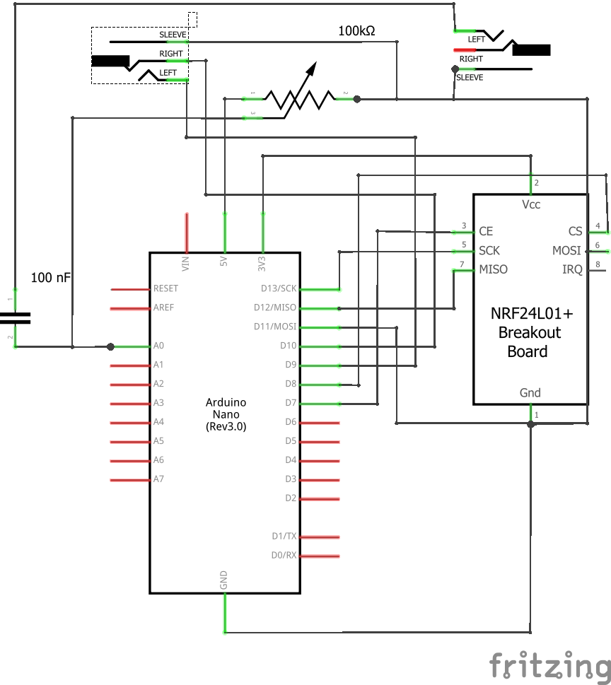

Figure - Schematic Diagram

## Component Connection Diagram

This diagram represents how sub-modules or components are connected in Transmitter module.

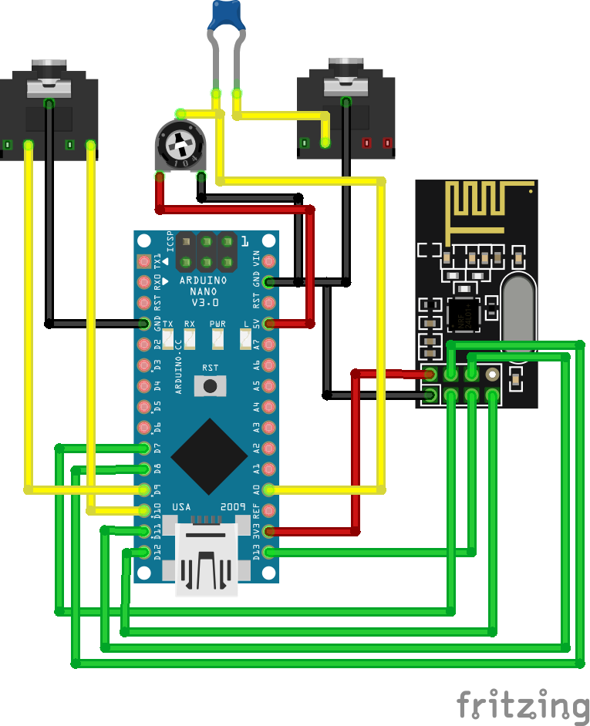

Figure - Component Connection Diagram

## Receiver

## Short Description

Receiver module receives audio data from transmitter. Although the Arduino nano mainboard is programmed differently but the circuit and composition of receiver module is identical to transmitter module.

## Schematic Diagram

Same as transmitter

## Component Connection Diagram

Same as transmitter

# Rules and Assumptions

Following are rules and cases of assumptions that are assumed to be true while normal working

* Transmitter is assumed to be powered with a LiPo battery hooked up with DC-DC boost converter circuit.
* Transmitter is attached to the collar or assumed to be close enough so that it would clearly get the voice.
* Receiver is assumed to be powered through USB.
* Output of the Receiver is fed to Line-in of PC.
* Transmitter and Receiver should be in the range of 5 meters to avoid noise and latency issue.
* Appropriate RS232 serial connection drivers are installed on the desktop to debug the Transmitter and Receiver module.

# Module Workflow Description

Board marker module hardware consists of **Transmitter** and **Receiver**.

## General Flow

* Transmitter try to connect to the Receiver
* After a successful connection, Transmitter reads analogue signal and converts it into digital PWM wave.
* Transmitter then starts transmitting the voice data through nRF24L01 module.
* Voice data arrives at nRF24L01 of Receiver.
* Receiver converts the incoming signal into audio wave.

## General Flow Diagram

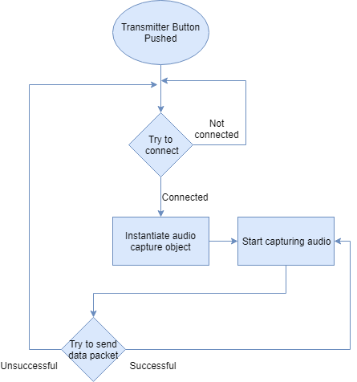

Figure - Transmitter Workflow

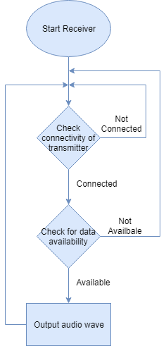

Figure - Receiver Workflow

# Tools and languages used

List all software that are used to develop and needed to operate the developed module are detailed below.

## Arduino IDE v1.8.9

Code environment in which all code for Board Maker Transmitter and Receiver is written. This IDE is numerously used as a debugging tool as well.

# References

List all documents that were used in defining the design documented in this document.